**BIOL_EN 8180**

# Fitting Models to Data

# 1. Linear Models

## Linear Fit – with Norris Dataset

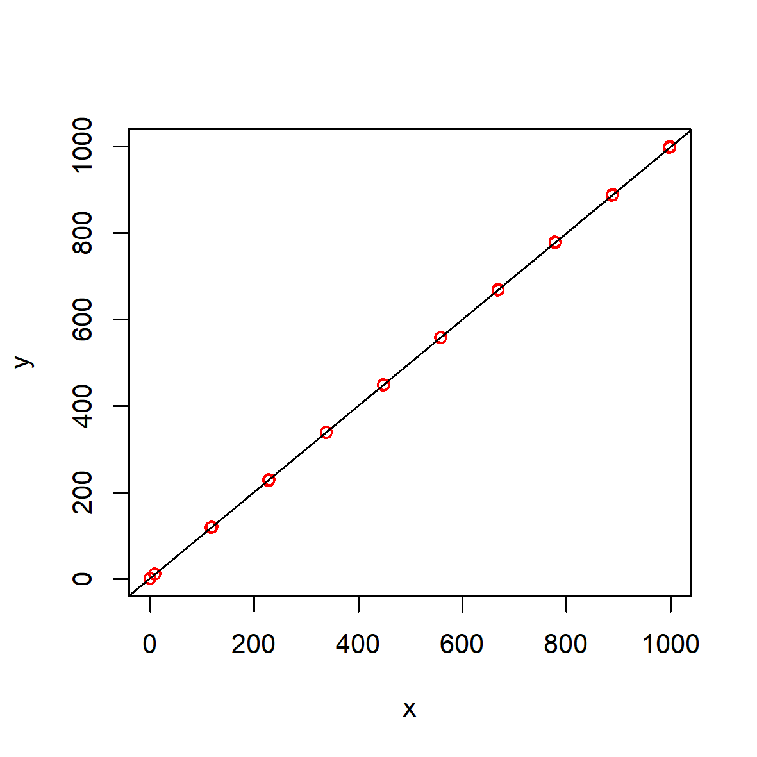

## Summary

## Linear Fit – with Fluxes at Watershed Outlet (TP ~ Water)

## Summary

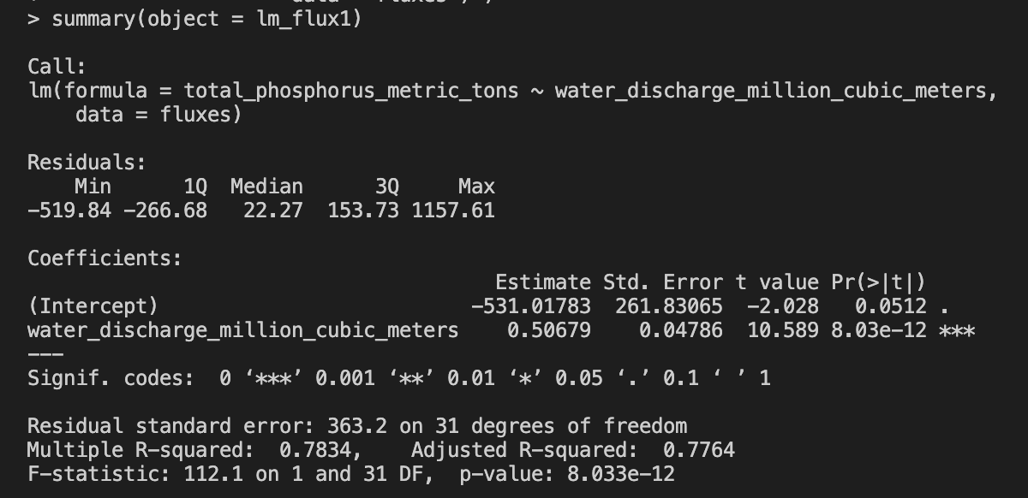

## Coefficients

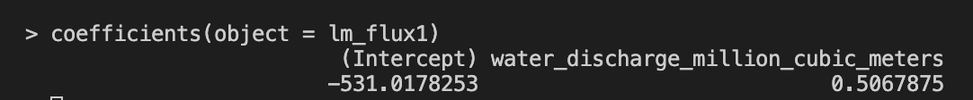

## Linear Fit – with Fluxes at Watershed Outlet (TN ~ Water)

## Summary

## Coefficients



## Non Linear Fit – with NIST Dataset (2nd order polynomial)

## Summary

## Non Linear Fit – with NIST Dataset (3nd order polynomial)

## 

## Summary

## Non Linear Fit – with NIST Dataset (3nd order polynomial)

## Summary

## Non Linear Fit – with Fluxes at Watershed Outlet (TP ~ Water) 2nd order polynomial

## Summary

## Non Linear Fit – with Fluxes at Watershed Outlet (ReP ~ Water) 2nd order polynomial

## Summary

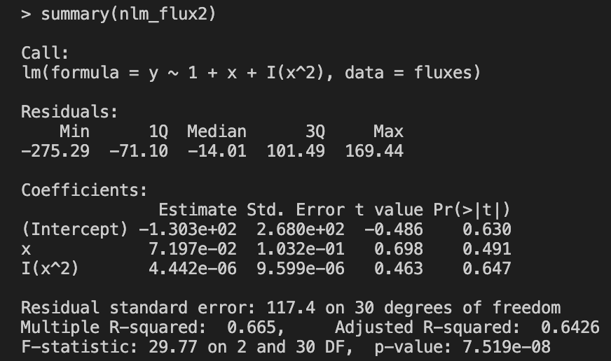

## Non Linear Fit – with NLS (ReP ~ Water) 2nd order polynomial

## Summary

## Non Linear Fit – with Fluxes at Watershed Outlet (TN ~ Water) 2nd order polynomial

## Summary

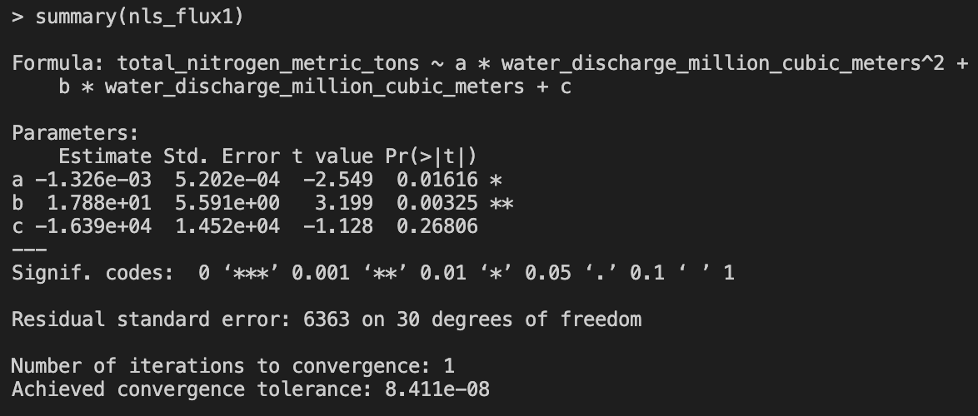

## Exponential function – with Fluxes at Watershed Outlet (ReP ~ Water)

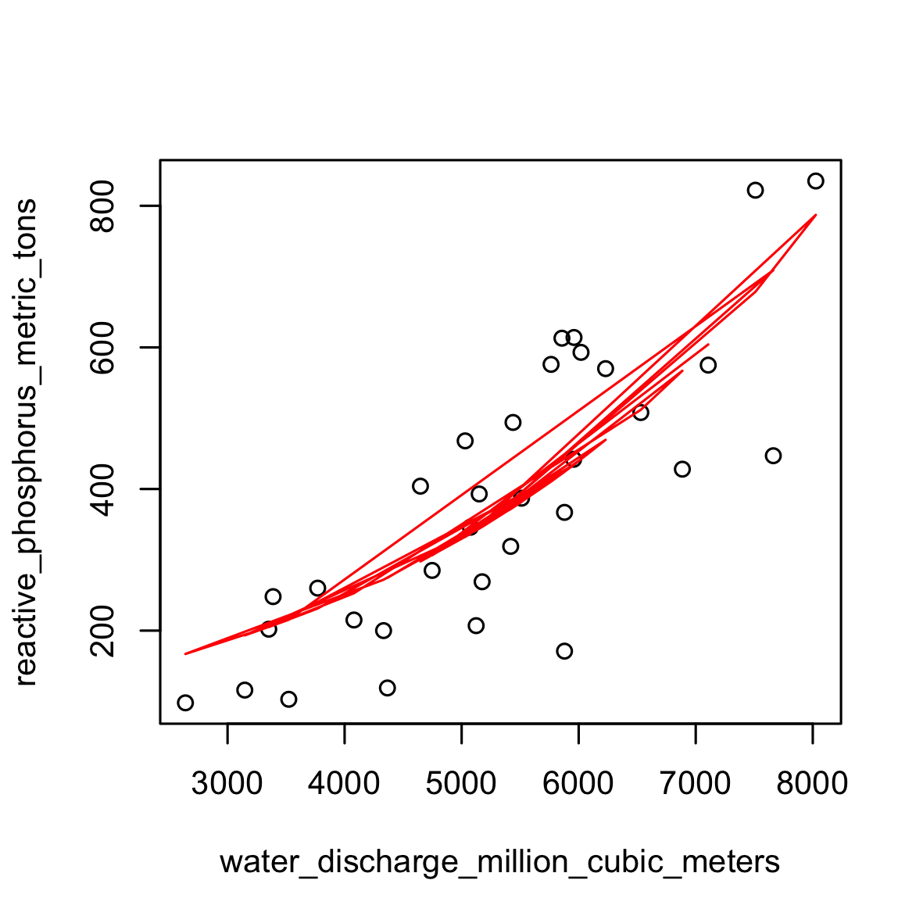

## Summary

## Exponential function – with Fluxes at Watershed Outlet (TP ~ Water)

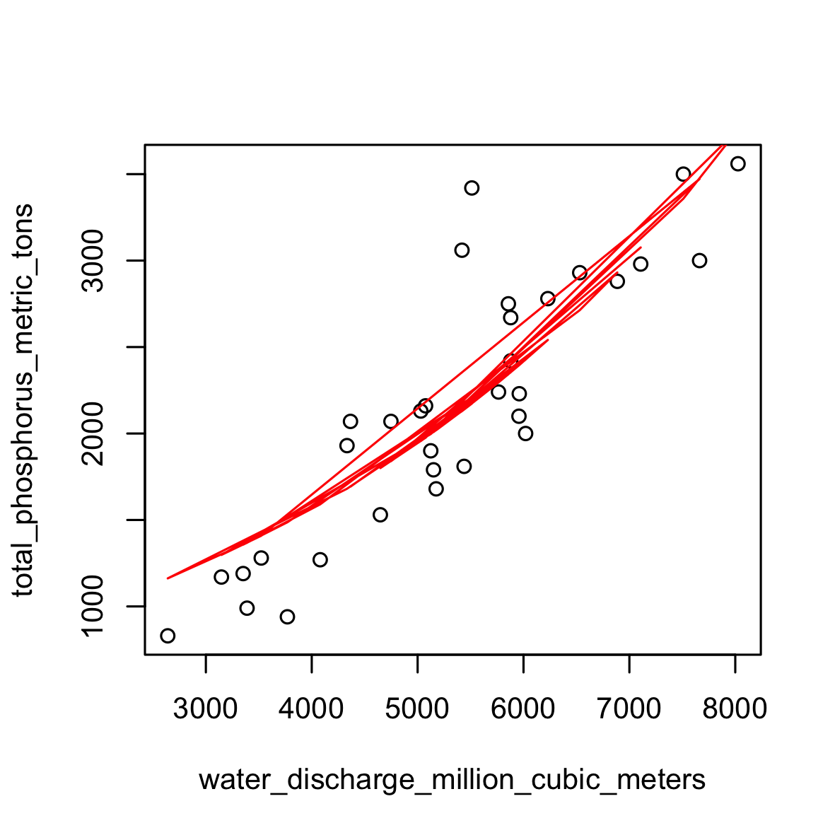

## Summary

